Tabular data E.g: excel sheets

While autoML vision and natural language are for unstructured data, AutoML Table is for structured data.

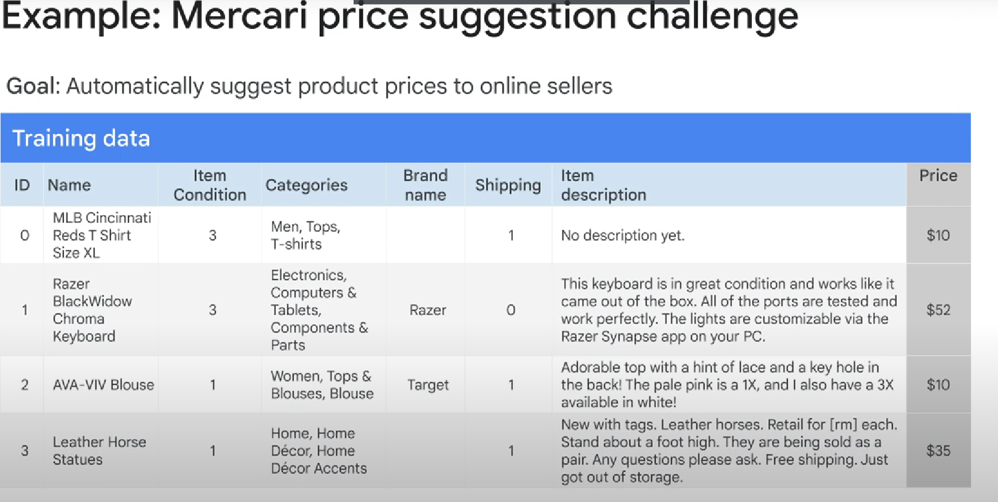

**The easiest way to import your data into AutoML Tables is through BigQuery**. You can also import data using CSV files stored locally or on **Cloud Storage**.

One of the advantages of importing data through BigQuery is its support for arrays and structs. Regardless, for both import sources, your data must have **between 1,000 and 100 million rows,** between **two and 1,000 columns**, and be **100 gigabytes or less in size**

you can train a model for a variable amount of time. You can set a training budget in node hours to cap costs. By default, AutoML Tables will stop training if the model isn't seeing significant performance gains anymore.